MEETING NOTICE

The next regular meeting of the Veterans Affairs Commission will be held on Thursday, November 10, 2011, 9:00am, at the Louisiana War Veterans Home, 4739 Highway 10, Jackson, in conjunction with the Home’s Annual Veterans Day Program. All interested persons are invited to attend.
602 North 5th St. • P. O. Box 94095 • Capitol Station • Baton Rouge, Louisiana 70804-9095
Telephone (225) 219-5000 • FAX (225) 219-5590

Bobby Jindal Lane Carson
GOVERNOR SECRETARY

Louisiana Department of Veterans Affairs

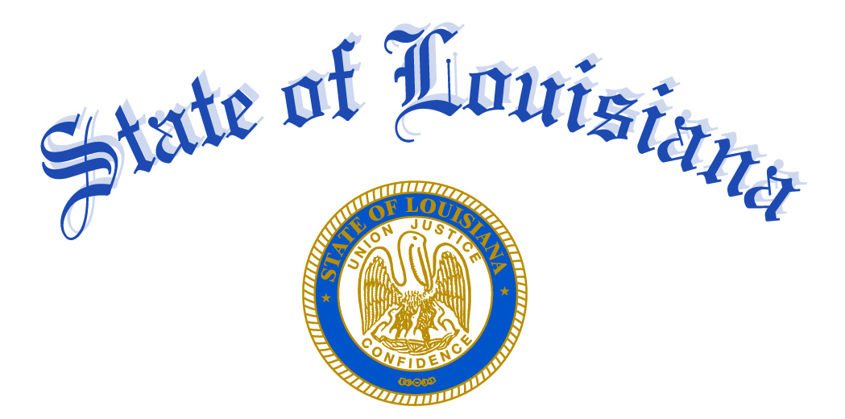

10/26/11

